NLS has just unveiled the prototype of our long-awaited Digital Talking Book player, or DTB. The most obvious feature of the new player is that it is substantial smaller and lighter than our current cassette players. The new DTB player measures a svelte 6 x 9 x 2 inches and weighs in at a smidgen over two pounds. That’s about one-third the size of the standard cassette player, which measures 9 x 11 x 3 inches and weighs 7 pounds.

The body of the player is dark charcoal grey for visual contrast between the case and the colors of the buttons.
A nifty feature of the new player is that the controls will talk back to you when you press them, telling you that you are setting the tone higher or the speed
slower, etc. The new DTB player also includes a sleep button that allows the

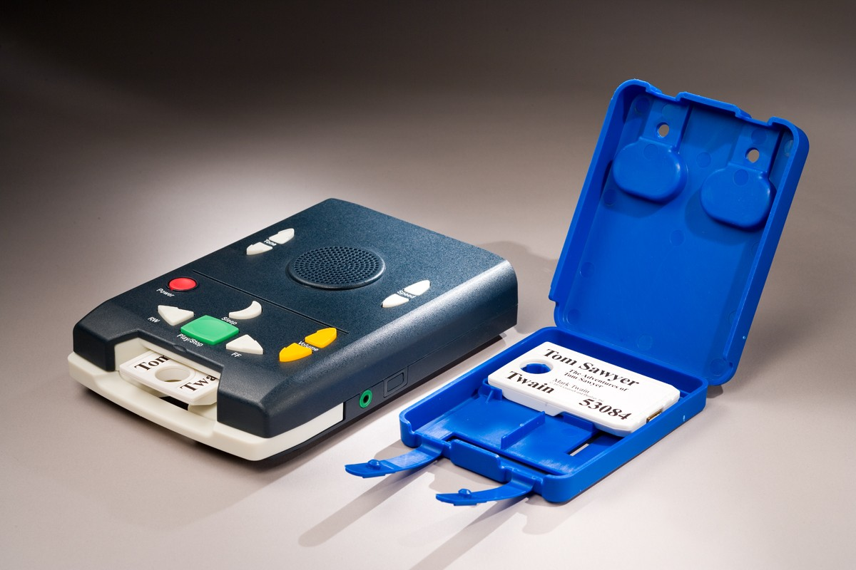

machine to turn itself off 30 minutes
after it is pressed. Since it has no
moving parts other than the controls, the new player should provide longer battery life and more reliability than our current players. That’s the good news.

The bad news is that we will not be receiving the players to distribute until the spring of 2008. And, we won’t have enough in the first year to distribute them to everyone. This means we will have audiocassette books and cassette players for some time after 2008.

Those of you on the Internet can access two color photographs and a detailed description of the new player at http://blindreaders.info/dtb.html. The rest of you can call your reader advisor for more information.

Holiday Schedule

The Library, like most State of Tennessee agencies, will be closed on November 23 and 24 for the Thanksgiving holiday and from December 22 through December 26 for the Christmas holiday. In addition, State offices will also be closed on Monday, January 1st for the New Year Holiday.

PAVEing the Way for Tennessee Kids, The Sequel

Last issue we told you about Project PAVE. Unfortunately, much of the information we gave you was out of date. We thank Cindy Bachofer of Vanderbilt for filling the potholes in our account.

“Project PAVE (Providing Access to the Visual Environment) is an outreach program that addresses the needs of students with visual impairments. The primary goals of Project PAVE are to provide clinical low vision evaluations, optical devices, and instruction in the use of these devices in the school setting as appropriate to the student. The ultimate goal is to prepare children for independent visual functioning.

“Project PAVE serves students ages 3-21 who reside in TN and who have been identified as visually impaired. The Project is a collaboration of the Department of Ophthalmology and Visual Sciences and the Department of Special Education, Peabody College, at Vanderbilt University. PAVE teachers provide services to 90 students each school year. Through federal appropriations, the Project receives funding through the Tennessee Department of Education.

“For additional information on services and eligibility, please contact Project PAVE at 615-936-3718 or toll free at 1-877-VU PAVE3. The fax number is 615-936-3466.”

Order Form Blues

As we mentioned in a previous article, we sometimes receive request order forms from patrons who have forgotten to include their names or return addresses. In some cases one of us can recognize the handwriting and make the connection. In the majority of cases, however, we are unable to track down the originator. So we can’t add these requests to a patron file.

Please do make a special effort to include your name and return address on all your correspondence with us, and especially on your order forms. It’s a bad feeling to know that somewhere out there one of you is waiting eagerly for books that aren’t yet on their way. And, if you think you haven’t received the books you ordered, keep in mind that this might just possibly be why!

Blindness and Women’s Health

Researchers at Brigham and Women’s Hospital and Harvard Medical School hope to survey 12,000 blind and visually impaired women in order to identify risk factors associated with certain health disorders, such as breast cancer and sleep problems. The results should help women to make more informed lifestyle choices.

The survey is open to all women aged 18 or older who are legally blind. Participants are being recruited in collaboration with the American Council of the Blind and the Perkins Braille and Talking Book Library. As an incentive to participate, all respondents will be entered to win prizes, which will include 50 subscriptions to the National Braille Press’s Our Special or Syndicated Columnists Weekly magazines. Two especially lucky winners will receive $250 gift certificates from EnableMart, a leading online vendor of assistive technology products.

You can register for and complete the survey over the Internet at bvihealthsurvey.com, in braille, by audio tape, in large print, or over the telephone. For more information contact the researchers by e-mail, bvihealthsurvey@rics.bwh.Harvard.edu, or by phone toll free at 1-888-828-4294.

Staff Profile

In an ongoing effort to promote diversity and equal opportunity, the LBPH has taken a drastic step. We have added a Yankee to our staff.

Donna Cirenza, who has replaced retiree Janie Murphree in September, 2006, as Assistant Director of the LBPH, originally hails from New York, albeit by way of Arizona and Knoxville.

Donna grew up and finished school in Yonkers, N.Y. before migrating south to College Park, Maryland, where she majored in French at the University of Maryland. Unlike many liberal arts majors, she immediately put her education to work by joining Dana Perfumes, where she served as director of marketing for such famous fragrances as Tabu, Canoe and Ambush.

After a working in this high-powered field for some time, Donna decided a change was in order and moved to Arizona. While there she decided to make a major career change (and we’re glad she did!) and headed back east to Knoxville to enter UT’s School of Information Sciences. Upon graduating in 2005 with an M.S. in Information Sciences, she joined TSLA as a Librarian in our Public Services department. Then, in 2006, we lured her into working in the LBPH.

As LBPH Assistant Director, Donna is responsible for managing our daily onsite operations, and for planning, developing, and implementing library programs. These operations include collection maintenance and development as well as recycling and disposal of damaged or surplus items.

Donna also supervises the reader advisors unit and maintains departmental attendance and leave records for the entire LBPH. (In other words, she’s yours truly’s boss, so be nice to her when you talk with her.)

Off duty, Donna enjoys orchids, art, and history. She has especially enjoyed touring many of Tennessee’s historic homes, including Blount Mansion and the Ramsay House Plantation in Knoxville and Traveler’s Rest and Belle Meade Plantation in Nashville.

Lest we think she has completely abandoned her Yankee roots, however, we have to let you in on her dirty little secret. She’s still a New York Yankees fan. (But that’s really okay; my mother was a Yankees fan too.)

LBPH Recommends

For mystery fans who also love old books, Donna recommends John Dunning’s “Bookman” series, featuring tough cop turned used-book dealer Cliff Janeway. LBPH has Booked to Die (RC 35454), Bookman’s Wake (RC 41100), Bookman’s Promise (RC58743), and Sign of the Book (RC 61567).
This publication was supported in whole or in part by the Institute of Museum and Library Services under the provisions of the Library Services and Technology Act as administered by the State of Tennessee.

Window to the World is published quarterly by the Tennessee Library for the Blind and Physically Handicapped, Tennessee State Library and Archives, Department of State. It is available on cassette, in braille, and on the web at www.tennessee.gov/TSLA/lbph. Please call the Library at (800) 342-3308 to request alternate formats.

Administration and Staff

The Honorable Riley C. Darnell, Secretary of State; Jeanne Sugg, State Librarian & Archivist; Ruth Hemphill, Director; Donna Cirenza, Assistant Director; Carmelita Esaw, Computer Specialist; Ann Jones, Administrative Assistant.

Circulation and Repair Staff: Larry Conner, Materials Manager; Jerry Clinard, Terry Corn, Ryan Darks, Dwight Davis, Ron Gross, and Billy Kirby.

Reader Advisors: Ed Byrne, Annette Hadley , Clara Ledbetter, and Francine Sharpe.

In providing information to readers, the announcement of products and services should not be considered an endorsement or recommendation by the Library.

